[](https://www.google.ch/url?sa=i&rct=j&q=&esrc=s&source=images&cd=&cad=rja&uact=8&ved=2ahUKEwis5pWo8I_eAhUOfFAKHeqlCdwQjRx6BAgBEAU&url=https://www.stericorp.net/biohazard-labels-1.html&psig=AOvVaw2PfwavpRXuHTt_yeipiY8f&ust=1539948217126918)[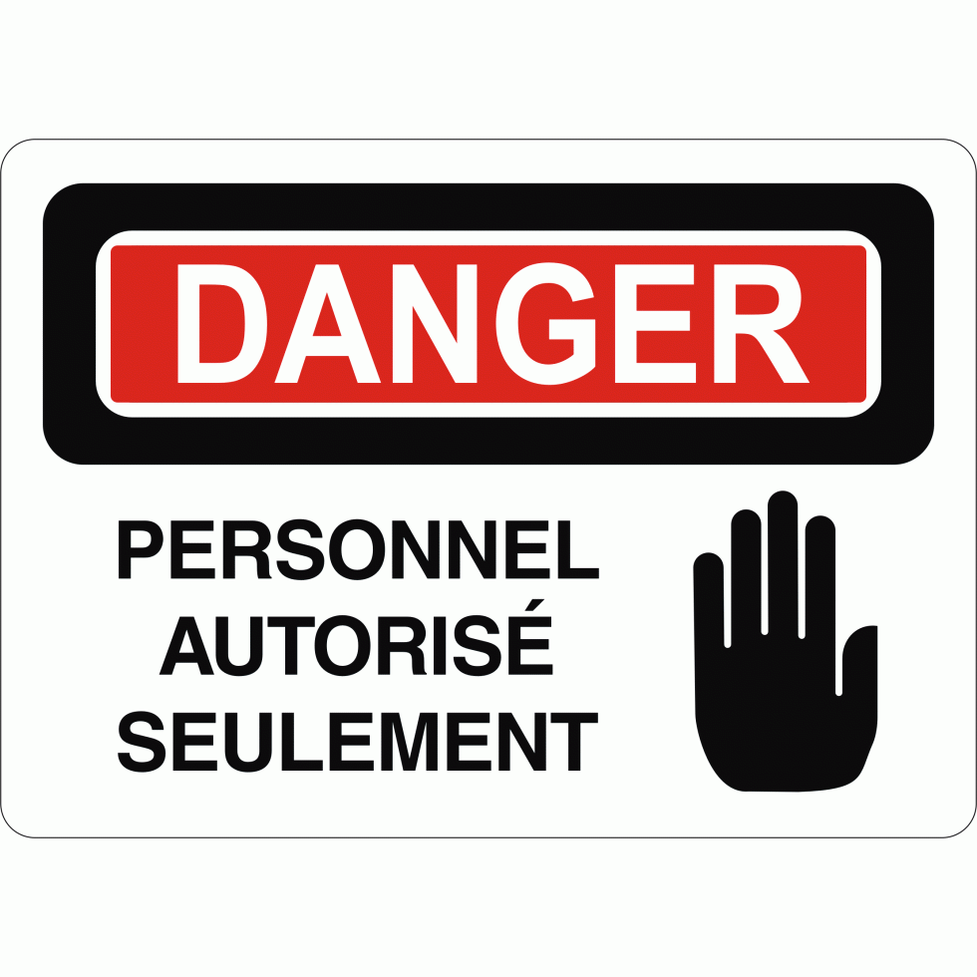](https://www.google.ch/url?sa=i&rct=j&q=&esrc=s&source=images&cd=&cad=rja&uact=8&ved=2ahUKEwiH0NaD8o_eAhVSa1AKHTyaDNsQjRx6BAgBEAU&url=https%3A%2F%2Falphasigna.com%2Fboutique%2Ffr%2Faffiche-de-securite-danger-personnel-autorise-seulement-p126%2F&psig=AOvVaw10L6L7dMRfaWudpd7SuiIG&ust=1539948628667660)

Zone de préparation